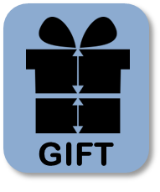

**GIFT User Manual**

**20.01.2022**

Contributors:

Jennifer Huling, Andreas Götz, Volkmar Senz, Wolfram Schmidt, Niels Grabow, Sabine Illner

Contact info:

Jennifer Huling, [Jennifer.huling@uni-rostock.de](mailto:Jennifer.huling@uni-rostock.de)

Andreas Götz, [Andreas.goetz@uni-rostock.de](mailto:Andreas.goetz@uni-rostock.de)

Sabine Illner, [sabine.Illner@uni-rostock.de](mailto:sabine.Illner@uni-rostock.de)

Contents

1. Overview 1

2. Installation 1

2.1 Installing ImageJ or FIJI 1

2.2 Installing necessary additional Plugin(s) 1

2.3 Installing the GIFT macro 2

3. The GIFT method and macro 3

3.1 The GIFT method 3

3.2 The GIFT macro 4

4. GIFT macro parameter definitions 6

Parameter 1: Input and output directories 6

Parameter 2: Saving process intermediates 7

Parameter 3: Add file name label 7

Parameter 4: Degree of Rotation 7

Parameter 5: Filter Line Length 8

Parameter 6: Threshold Percent 9

Parameter 7: Manually set threshold percent 10

Parameter 8: Histogram bin size 10

Parameter 9: Set image scale 11

Parameter 10: Manually set scale 11

Parameter 11: Set crop area 11

Parameter 12: Manually select crop area 11

Parameter 13: Fiber Diameter Orientation measurement: 12

5. Explanation of macro outputs 12

4.1 Histograms 12

4.2 Results Table 12

4.3 Complete Data Files 13

4.4 Image Processing Intermediates 13

6. Troubleshooting 13

6.1 File Type Compatibility 13

6.2 GUI size/visibility 14

6.3 Incomplete image cropping 14

6.4 Bin number error 14

6.5 Bimodal distributions 15

References 16

# Overview

General Image Fiber Tool (GIFT) is an ImageJ macro tool which allows the user to measure the average diameter of electrospun fibers in scanning electron microscopy (SEM) images. The theory and method behind GIFT is thoroughly explained and validated in our previously published work (Götz et al, 2021. <https://doi.org/10.1016/j.measurement.2021.109265>) [1]. Measuring fiber diameters as an experimental endpoint or as a means of quality control is an important step in the fabrication of nonwoven materials. GIFT allows for the quick and reliable batch analysis of large sets of images and allows users control over the image analysis parameters. Results are presented in summarized or raw data formats. GIFT may also be applied to non-electrospinning images, and examples are given in the supplemental info section of Götz et al 2021 [1].

Please credit and cite the following paper when using GIFT:

A. Götz, V. Senz, W. Schmidt, J. Huling, N. Grabow, S. Illner, General image fiber tool: A concept for automated evaluation of fiber diameters in SEM images, Measurement 177 (2021) 109265. https://doi.org/10.1016/j.measurement.2021.109265.

# Installation

## 2.1 Installing ImageJ or FIJI

The GIFT macro runs through the software ImageJ [2]. ImageJ is freely available for download at <https://imagej.nih.gov/>. For installation instructions see <https://imagej.nih.gov/ij/docs/install/index.html>. The GIFT macro can also be run through the software Fiji, which runs ImageJ with many plugins already installed [3]. For instructions to download see <https://fiji.sc/>. Fiji is recommended.

## 2.2 Installing necessary additional Plugin(s)

GIFT requires other freely available ImageJ plugins to function. At minimum GIFT requires the installation of the plugin MorphoLibJ [4]. All information, installation instructions and files for MorphoLibJ can be found here <https://github.com/ijpb/MorphoLibJ>. To install in ImageJ, simply click the link for the newest release, under the Installation heading (<https://github.com/ijpb/MorphoLibJ/releases>). Find and download the .jar file in the lists of Assets under the newest release listing. Put the .jar file in the Plugins folder under ImageJ (Imagej>Plugins) folder. Restart ImageJ. To install in Fiji, use the Updater. Go to Help>Update… in the Fiji menu. Select Manage Update sites, and then check the box next to IJPB-plugins and hit close. Click Apply changes and restart Fiji. If MorpholibJ is not correctly installed, the user will see the error *Unrecognized command:”Morphological Filters”* when the macro is run.

GIFT can run two fiber orientation plugins to collect orientation data along with measuring fiber diameters (OrientationJ and Directionality). This is optional and if the user does not want to measure fiber orientation, then these plugins do not need to be downloaded or just one can be added. Information about OrientationJ can be found here: <http://bigwww.epfl.ch/demo/orientation/> (OrientationJ_.jar available for download directly at this website under the Download section on the lefthand side). Put the .jar file in the Plugins folder under ImageJ (Imagej>Plugins) folder. Information about Directionality can be found here: <https://imagej.net/plugins/directionality>. It is recommended that Fiji is used to access Directionality as it is already included as part of Fiji and requires no further action to install.

## 2.3 Installing the GIFT macro

There are several options for running the GIFT macro through ImageJ or FIJI. All options start with downloading the GIFT.ijm file found here: <https://github.com/IBMTRostock/GIFT>. The file can be saved anywhere on your computer.

To temporarily install the macro, go to Plugins>Macros>Install… and then select the GIFT.ijm file and click Open. The GIFT tool icon (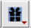) should now appear in the first blank tool slot on the left hand side of the ImageJ toolbar. Clicking on the icon will reveal a dropdown menu with the 2 options for running GIFT: “Process Single Open Image” and “Batch Process”. Clicking on either of these will start GIFT. When installed this way, the GIFT icon will disappear if ImageJ is restarted and must be installed again the next time the ImageJ is open.

To add GIFT to the list of start-up macros that automatically load every time ImageJ is started, open the StartupMacros file using Plugins>Macro>Startup Macros… While in the code editing window that shows the StartupMacros file, open the GIFT macro GIFT.ijm file using File>Open>select GIFT.ijm file. Both files should now be open. In GIFT macro file highlight all of the text (CTRL+A) and copy the selection (CTRL+C). Move to the StartupMacros file, select a blank line at the very end of the file and paste the GIFT text (CTRL+V). Use File>Save on the StartupMacros file, then close and restart ImageJ. The GIFT tool icon () should now appear in the first blank tool slot on the left hand side of the ImageJ toolbar.

# The GIFT method and macro

## 3.1 The GIFT method



**Figure 1:** This figure is reprinted with permission and was originally published in Measurement, Vol 177, Andreas Götz, Volkmar Senz, Wolfram Schmidt, Jennifer Huling, Niels Grabow, Sabine Illner, General image fiber tool: A concept for automated evaluation of fiber diameters in SEM images, Copyright (2021) [1]. This diagram outlines the concept and method used by GIFT to measure fiber diameters in SEM images of electrospun fibers.

For a complete and detailed description of the GIFT method and its validation, see Götz et al, 2021 [1]. Briefly, the 8-bit image is processed with a Sobel operator to identify the edges (“Find Edges” in ImageJ), followed by thresholding to create a binary image containing the fiber edges. In the macro, the threshold range is determined based on a percent of included pixels (see Parameter 6). This binarized image is then rotated to create a set of rotated copies (see Parameter 4). The separate ImageJ plug-in, MorphoLibJ [4], is used to apply a horizontal opening line filter (see Parameter 5). This step isolates line segments that are roughly horizontal at each rotation angle. In doing this, the parallel edges of any fiber segments running horizontally will be preserved after the filtering step. Then, in each image of the rotated set, the macro scans through each pixel column and identifies the maxima, which correspond to the locations of edges in the original image. The vertical pixel distances between maxima are measured and converted into a real distance based on the scaling factor (see Parameter 9). This creates a large raw data set of measured distances between edges in the image. Some of these distances represent the distance between the two edges of one fiber (fiber diameter) and some represented the distance between edges of neighboring fibers (background). Because the fiber diameter is relatively constant, it should appear with a significantly higher frequency in this data set, while the background distances have a more random distribution. To identify the fiber diameter, a histogram is plotted of all of the distance measurements and fitted using a Gaussian model. The peak location of the Gaussian fit represents the mean fiber diameter and the peak width represents the standard deviation.

## 3.2 The GIFT macro

After validating the concept behind GIFT, the goal was to make the method user friendly and accessible. Given its wide use, ImageJ was an ideal platform. GIFT was converted into a macro which can be run directly from ImageJ. When the GIFT macro icon is selected, there are two options: “Process Single Open Image” and “Batch Process”. Both run the exact same method and will generate the same results, but offer more flexibility to the user. The single image mode can be useful when first evaluating the parameters best suited for an image set, however the focus of this user guide is on the batch processing mode of the GIFT and, unless specified, the instructions and explanations are for the batch mode.

The GIFT macro was designed so that users could get started easily, with a very small learning curve. When running the batch mode of GIFT, the only required user inputs are the Input and Output directories (see Parameter 1). All other necessary parameters are assigned default values so the program can be run without further input and the default image processing values are based on the results from Götz et al, 2021 [1]. In the next section, each parameter is described.

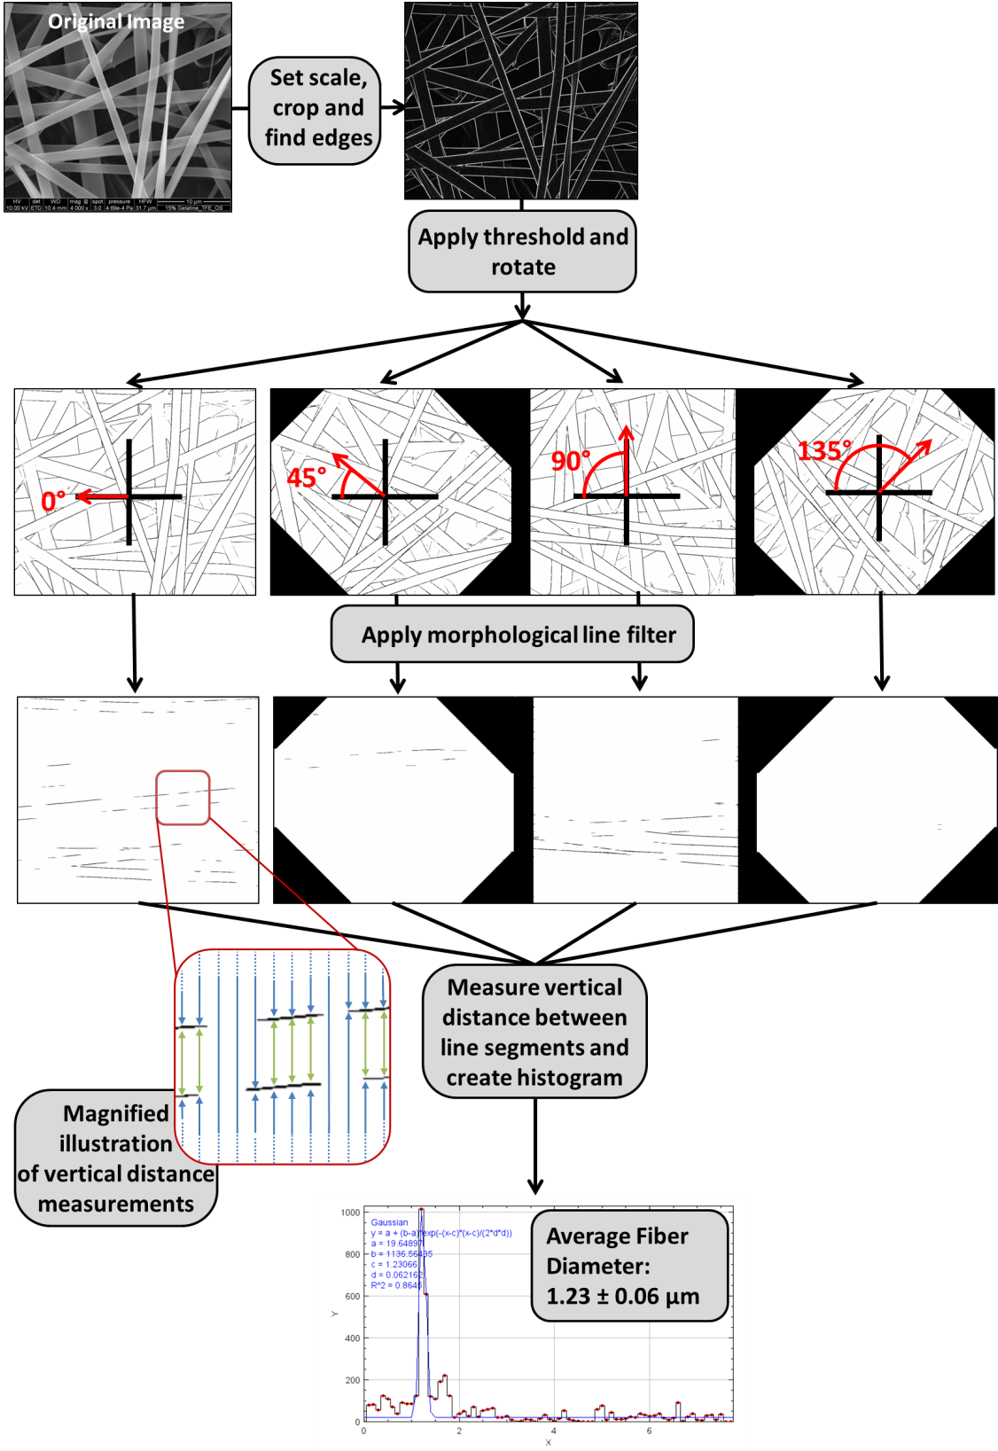

**Figure 2:** This figure shows a real world example of what the GIFT method looks like when applied to a single image. First the image is prepared by measuring the scale and then cropping off the information at the bottom of the image. A Sobel operator is applied to detect the edges in the image (“Find Edges” function in ImageJ). Then the image is thresholded and rotated, resulting in a set of thresholded images at various angles of rotation. Each of these rotated images goes through morphological opening filtering based on a horizontal line element. Then every pixel column in each filtered image is scanned for black pixels. The vertical distances between the black pixels (which correspond to edges in the original image) are measured. This process is illustrated in the inset image, where the green arrows highlight high frequency distance measurements that occur due to fibers. All measurements from the rotated image set are pooled together. These measurements are graphed as a histogram and a Gaussian fit is used to find the peak.

# GIFT macro parameter definitions

In this section every adjustable parameter and setting in GIFT is explained in detail. An image of the graphical user interface (GUI) for the macro is shown in Figure 3. Each user-defined parameter is marked with a number and explained in its own section below.

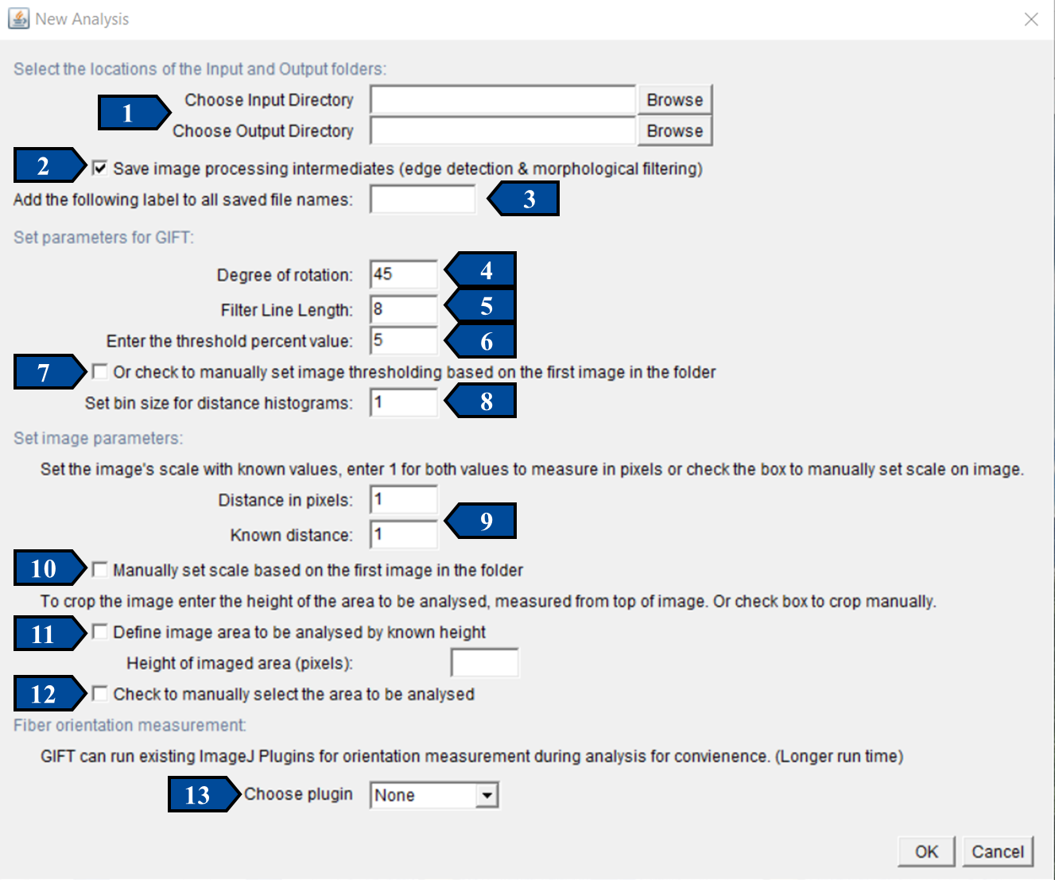

**Figure 3:** Graphical user interface (GUI) for batch mode operation of GIFT. This single GUI is used to set all of the parameters related to image processing and macro output. Each user-defined parameter is labeled with a number. For specific information about any parameter, see detailed description and examples below. Parameter 1 (Input and output directories) must be specified by the user to run GIFT, however all other parameters and settings have default values assigned. Therefore the minimum input required from the use is simply to choose the Input/output directories and click OK.

## Parameter 1: Input and output directories

The input directory is the location (folder) where the images to be analyzed are saved. This folder should only have image files in it. The GIFT macro is compatible with .tif, .PNG, .JPEG and .BMP image file types. To select, click the browse button, then navigate to your desired folder and hit “select”. The file path should then appear in the Input Directory text field.

The output directory is where the images from the image processing steps during analysis will be saved (if that option is chosen) along with the data files from the analysis (if that option is chosen). Histograms from the analysis process will always be saved in the output directory. It is recommended that a new folder specifically for the output data is created as GIFT can create a large amount of images during analysis. The output directory is selected in the same manner as the input directory.

## Parameter 2: Saving process intermediates

This option allows the user to decide if they want to save the image process intermediate steps that occur during the analysis. It is selected by default and if selected two image types will be saved into the output directory for each image processed. The first image type shows the results of cropping, edge detection and thresholding settings. These images will have the word “Edges” appended to the file name along with the rotation angle (i.e. “Filename_Edges_90.tif”). The second type of image shows the results of the morphological filtering step to isolate horizontal line segments. These images will have the word “Filtered” appended to the file name along with the rotation angle (i.e “Filename_Filtered_90.tif). The number of saved images depends on the number of images processed and the processing angle chosen. For examples, a set of 10 images with a processing angle of 45° (so 4 measured angles) will results in 80 images. If the save image checkbox is unchecked, no processing images will be saved.

## Parameter 3: Add file name label

This option allows the user to add a text label to the beginning of all saved files for the subsequent analysis. If this text field is left blank, no text is added. If filled, the chosen text will be appended to the beginning of every image name (i.e. “LABEL_Filename_Edges_90.tif”) and to the beginning of any saved data files (i.e. “LABEL_CompleteDataFile.txt”). This can be useful to distinguish between results generated from the same image set, but analyzed with different parameter settings. Comparing the resulting images can be useful when determining the best parameters to use. Without a label to modify the file name, the files from the new analysis will save over the previous files with the same name.

## Parameter 4: Degree of Rotation

This parameter directly effects the image processing. The degree of rotation refers to the angle by which the image is rotated during one of the processing steps. Every image processed by GIFT is rotated to form a series of rotated copies of the initial image. Because GIFT relies on identifying parallel line fragments using horizontal morphological filtering, creating several rotated copies before the filtering step ensures that parallel edge fragments are identified at several different angles in the image. See Figure 2 for an example of where the rotation step falls into the image processing of GIFT.

The default setting is 45° which results in a set of 4 rotated copies for each image (0°, 45°, 90°, 135°). This can be changed to any angle that is greater than 0. For example, a degree of rotation of 10° would create a set of 18 rotated copies for each processed image. Our validation in Götz et al. showed that a 45° angle of rotation is typically sufficient for accurate results, however decreasing the degree of rotation and therefore increasing the number of copied images can increase accuracy in some cases. The trade-off, however, is that this will significantly increase the processing time per image. It is not recommended that a degree of rotation less than 6° is used, because that will likely lead to redundant measurement of edge segments.

## Parameter 5: Filter Line Length

This parameter directly effects the image processing. The number entered for “Filtered Line Length” sets the pixel length of the horizontal line used to perform the morphological filtering step. This filtering step is applied to the images after edge detection and thresholding. This processing step essentially isolates only line segments that are roughly horizontal. A shorter filter line length is less restrictive and will result in more line segments remaining after the filtering step. However, the shorter the filter line, the more likely it will be to fit inside an element of the thresholded image, even if that element is not perfectly horizontal. This can lead to measured distances slightly overestimating fiber diameter (See Götz et. al. for a more detailed discussion of the relationship between filter line length and error). A longer filter line length is more restrictive and will filter out more of the thresholded image. Figure 4 shows an example of one image processed with variable filter line lengths to illustrate to effect of this parameter.

The morphological filtering step is performed using the MorphoLibJ plugin, which must be installed separately when using normal ImageJ [4] (see Installation section for instructions). A morphological opening process is used (erosion step followed by dilation step). For more information on the plugin and process see <https://imagej.net/plugins/morpholibj#Morphological_filters>.

The default setting for the Filter Line Length is 8 px. Validation in Götz et al. showed that this value generates accurate results in most cases. However, the values can be set to any number greater than 0 px.

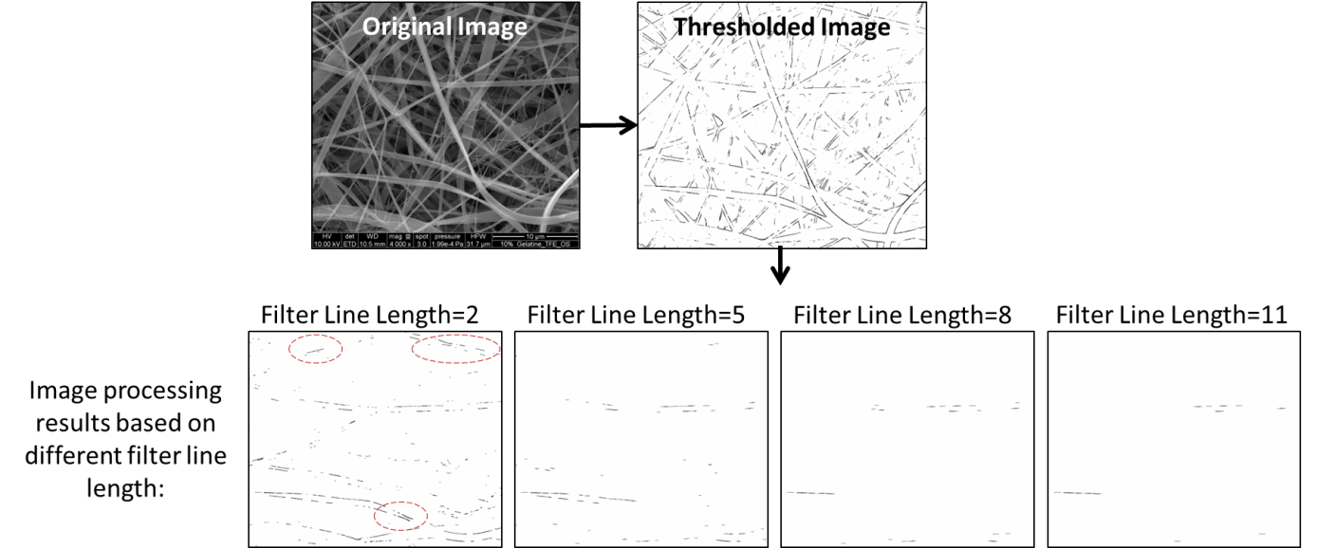

**Figure 4:** This examples shows one image processed using various morphological filter line lengths (2, 5, 8 or 11 px). The images after filtering demonstrate how the line length affects the results. Short filter line lengths are less restrictive and result in more line segments after filtering. However, these line segments can be seen to represent some non-horizontal elements (3 examples indicated with red circles). In this example, filter line lengths of 5 or 8 appear to adequately eliminate non horizontal elements during the filtering step, while not losing too much data in the process.

## Parameter 6: Threshold Percent

This parameter directly effects the image processing. All images are processed using the “Find Edges” function in ImageJ and are then thresholded to contain only the whitest pixels (which represent the edges) and therefore includes pixels in the range of 255 to some adjustable lower value. The exact range is determined based on the user-defined threshold percent value. The threshold cutoff is calculated so that the specified percent of pixels are within the threshold range. For example, the default value is 5%, which means that the lower threshold cutoff is set so that the range from the cutoff to 255 contains 5% of the pixels in the image. The upper end of the range is always 255. Threshold percent calculations are always done based on a cropped version of the image (if the user indicates a cropping option). Figure 5 shows an example of how the threshold percent effects the image processing. The program uses a percent based system, rather than a fixed pixel value because this is a more flexible way to handle batches of images with variable grayscale distributions. The exact pixel value cut off is calculated for each image based on the given percent values and should produce consistent results when applied to large batches of images.

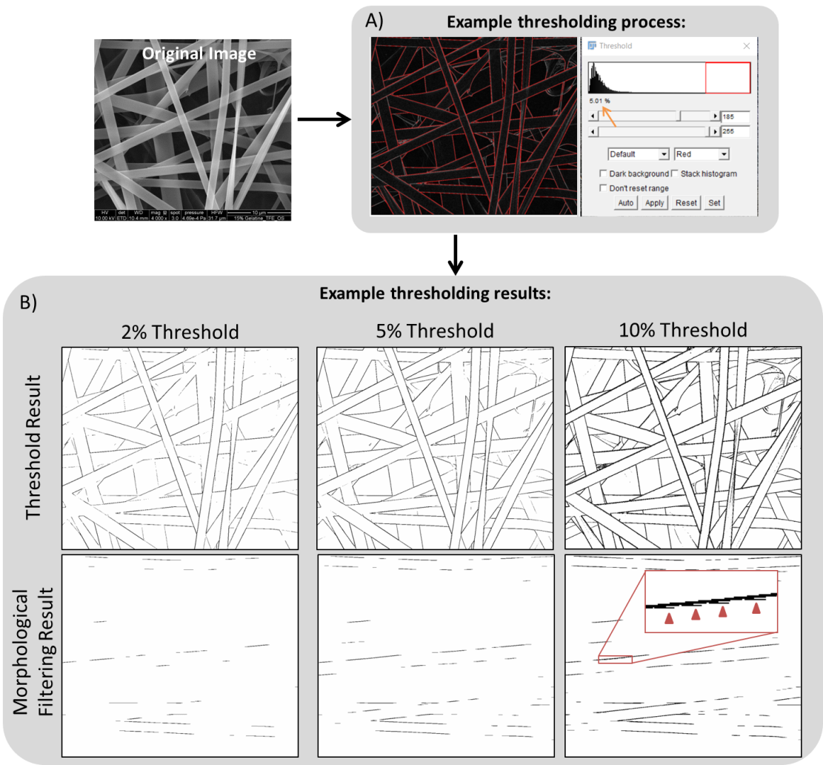

**Figure 5:** Box A shows an example of the thresholding process used in GIFT. In this example the threshold is set to include 5% of pixels (orange arrow). Box B shows the thresholding and filtering results when the example image was processed with 2, 5 or 10% as the threshold percent parameter. Having the threshold percent set too high can increase error by leading to thick line segments and artifacts like the ones indicated with red arrowheads in the inset. The small single pixel gaps in this line segment will generate many very short distance measurements which could appear as an erroneous peak on the histogram.

## Parameter 7: Manually set threshold percent

Rather than entering a percent value on the main GUI, the user can check this box to manually adjust the threshold parameter. If checked, the program will open the first image in the input folder and show it processed up until the thresholding stage. Then the user will be prompted to adjust the threshold window sliders until the desired thresholding is achieved (see Box A in Figure 5). The user should keep the bottom slider set at 255 and only adjust the top slider. The goal is to have the selected red region highlight only the fiber edges and avoid including surface texture or background. When the desired values are set, click OK on the instructional popup window (NOT on the threshold window) to continue with the program.

The threshold value will be calculated based on this first image and applied to the rest of the images. Only the initial image is used as an example to set the threshold percent during batch processing. If the user wants to check how different values look on multiple images, it is suggested that those individual images are opened in ImageJ and evaluated using single image mode. This can be useful to determine the best parameter to use for subsequent batch processing.

## Parameter 8: Histogram bin size

A defined bin size is necessary to create the final histogram from all measured vertical distances. This is the histogram used to determine the average fiber diameter based on the Gaussian fit peak. An appropriate bin size is necessary to accurately see the peak associated with average fiber diameter. The bin size should be chosen so that it is appropriate for the scale used for the image (see Parameter 9). The default GIFT settings do not include a scale and calculate distance in pixels and the bin size is set to 1 (px). If the scale of the image is given, then the bin size should be adjusted. For standard SEM images of electrospun fibers, a bin size of 0.1 (µm) works well, assuming a scale in pixels per µm is also provided as Parameter 9. Figure 6 shows the same image data, but graphed with different scale and bin size combinations to illustrate the effect of bin size.

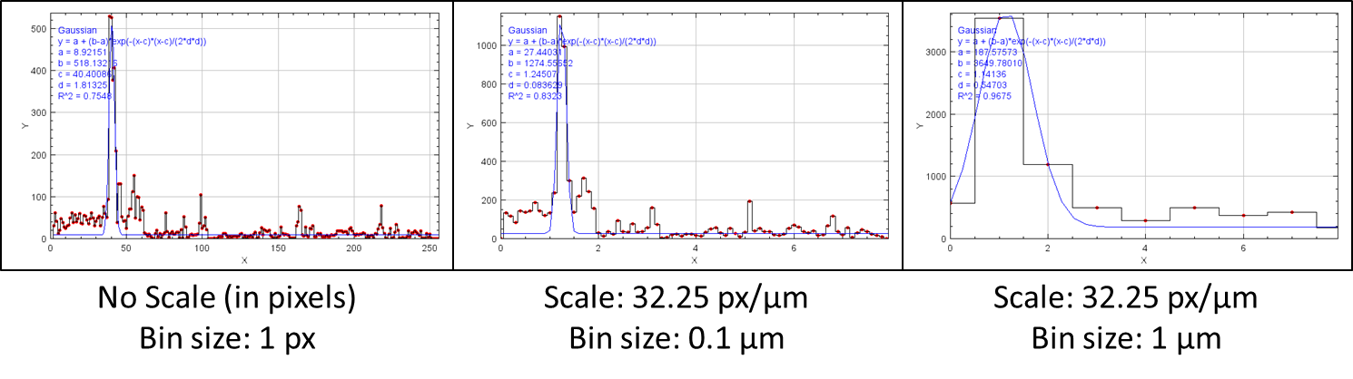

**Figure 6:** It is important to make sure the histogram bin size used is appropriate for the scale of the image. The default settings will calculate the fiber diameter in pixels (left histogram). The user can also provide a known scale. The middle histrogram shows an example with the scale provided in px/µm and the bin size adjusted to 0.1 µm. The right examples shows a histogram generated with a known scale in px/µm, but the bin size left at 1 µm. This bin size is too large and generates a wide, inaccurate peak.

## Parameter 9: Set image scale

A scale can be proved with the images so that the average fiber diameter is given in real world units. The default scale settings in GIFT are to run with no scale and simply measure distances in pixels. To do this a value of 1 is entered for both distance in pixels and known distance (which creates a scale of 1 px/px).

However, if the scale is known that information can be entered before image processing. For example, if it is known that 500 px in the images equal 10 µm, then the value 500 can be placed in the “Distance in Pixels” box and the value 10 can be placed in the “Known distance” box. In this example, the user could also enter 50 as the distance pixel and 1 as the known distance and it will produce the same results. In this example, all of the results will then be in µm. However, the program will not label the results as µm, the results are simply given as numbers and the user must know what units the provided scale was in. When specifying the known scale of an image, be sure to consider histogram bin size (see parameter 8).

The same scale is applied to all the images in the Input folder during batch mode. Currently there is no way to batch process images with differing scales. Instead, the user could measure everything in pixel distances and then convert those values later for each image.

## Parameter 10: Manually set scale

If the scale of the image is not known, but there is a scale bar on the images the user can measure the scale bar manually before the batch processing begins. If the user checks the box next to “manually set scale” and clicks OK, the first image in the Input folder will be opened so that the scale can be set before processing. The user should use the line tool (automatically selected) and draw a line the exact length of the scale bar on the image. The user can use the ImageJ zoom function to make this process easier. Once the line is placed, click OK on the instructional popup window to continue with processing. The user will then be asked to provide the unit length of the drawn line. Then this information will be used to calculate the scale of all subsequent images.

## Parameter 11: Set crop area

Many SEM images contain image data or scale bars at the bottom of the image. It is important to remove this portion of the image before processing as it will impact the results (see section 6.3 for example). To do this, all images can be cropped based on a user provided height. Check the box to automatically crop all images to the same height and then provide a pixel value to define the distance as measured from the top of the image. For example, if a 1000x1000 pixel image has image data at the bottom that is 100 px tall the user can check the crop function and then enter 900 into the box. This defines a crop window that starts in the top left corner and is 900 px tall and 1000 px wide (full width). This 900 x 1000 px area is what will be processed and the bottom 100 px tall area is cropped out. The same area will be applied to all images in the Input folder.

## Parameter 12: Manually select crop area

If the images need to be cropped before processing, but the exact height is not known or the data/scale bar are not located along the bottom of the image, then the user can manually define the crop area. Check the manually select area box and then click OK. The first image in the input folder will be opened as an example. The user should select the region of the image to be measured (exclude the scale bar area) using the box tool (automatically selected). Once the correct area is selected the user should click OK. This area will be used to crop all images before processing.

## Parameter 13: Fiber Diameter Orientation measurement:

The GIFT macro does not measure the orientation of fibers, but can run existing orientation plugins in parallel to the fiber diameter measurements. To do this the user must have installed the corresponding plugin (see Installation section 2.2). The user can run either Directionality or OrientationJ. The results are incorporated into the results table for each image processed. Running the orientation plugins in parallel significantly increases the processing time per image.

OrientationJ is the best option for large data sets, as it much faster per image than Directionality. In addition to requiring more processing time, running Directionality will result in a histogram and data table remaining open on screen for each image process. For this reason it is not suitable for large datasets.

# Explanation of macro outputs

## 4.1 Histograms

As part of GIFT, a histogram of distances is generated for each image. A Gaussian fit of this histogram is what is used to quantify the fiber diameter and standard deviation. The histogram and Gaussian fit line (blue line) are plotted together and for each image the resulting graph is saved in two forms which both appear in the selected output folder. The first form is the resulting .png file (example: Histogram_filename.png). These image files can be opened normally for immediate viewing and use. The second form is the .tif file (example: Histogram_modifiable_filename.tif). This file should be opened in ImageJ if the user wants to modify the graph. Once open in ImageJ, users can retrieve the data from the graph, change the graph axis ranges, axis properties, etc. In the upper left corner of the histograms the Gaussian fit data is displayed. The equation and calculated parameters are listed. The parameter c is the peak location and d is the peak width. They are recorded in the results as mean diameter and standard deviation, respectively.

It should be noted that the modifiable file is the easiest way to adjust the x range for the histograms. GIFT automatically sets the range to be ¼ of the width of the image being analyzed (based on the scale indicated). In some cases this might not be ideal and the user can specify the x axis range when the .tif histogram file is open in ImageJ by selecting More > Set Range. Alternatively, the data necessary to recreate the same graph (histogram + fit line) for each image is contained in the CompleteFrequencyData (see Complete Data Files section) table if the user chose to save that as part of the output. The bin size used for the histogram cannot be changed after the fact and must be provided in the initial GUI. Alternatively, the raw data (see Complete Data Files section) can be used to create histograms in other software if desired, allowing for complete control of histogram, fit and visualization.

## 4.2 Results Table

A summary table with the title Results will be created and displayed after running the GIFT macro. This table contains a row for each image processed and columns containing the mean fiber diameter, standard deviation (SDEV) of the fiber diameter, and the R2 value for the Gaussian fit and the number of observation made (total number of distances measured) for each image. Additionally, if a fiber orientation method was used, then the Orientation mean (in degrees), orientation standard deviation (in degrees) and orientation fit R2 value will be shown for each image. After the last data entry in the Results table there is a blank row followed by a record of the image analysis parameters used to generate the above data. The Results table can be saved as .txt, .csv or .xls file in the output folder at the end of the analysis process (saved under name “BatchResults”).

## 4.3 Complete Data Files

Every time GIFT is run, it generates several tables containing completes sets of data, in addition to the summary data in the Results table. The macro will always generate a CompleteDataFile table and a CompleteFrequencyFile table. The CompleteDataFile table contains the raw data used to create the distance histogram. There will be one column per image analyzed and the column contains every vertical distance measurement made. This raw data set is what is used to create the distance histogram and is available so that users could choose to make their own histogram, with complete control over the data analysis parameters. The number of values in each column is listed in the summary table as # of observations.

The CompleteFrequencyFile table has the data pertaining to the distance histogram and Gaussian fit. The first column, called “distance”, corresponds to the histogram bins and is given in the units specified at the beginning of the analysis. Each analyzed image will have 2 columns of data in the table. The first lists the frequency which corresponds with each bin and the second column (“_Fit”) gives the values of Gaussian fit curve at each bin value. These values can be used to directly recreate the histogram and fit curve that the GIFT macro creates for each graph. ImageJ is not designed for flexible data visualization or analysis, so the macro is designed to provide users with supporting data sets that can be used to make customized graphs or to perform further analysis in other software packages.

Additionally, if the user chose a fiber orientation analysis method, the CompleteOrientationFile table will also be generated. This table is similar to the CompleteFrequencyFile and has the data needed to recreate the orientation histogram and fit generated with either OrientationJ or Directionality.

All of these tables will be present on screen as the end of the analysis and can be saved as .txt, .csv or .xls files in the output folder at the end of the analysis process.

## 4.4 Image Processing Intermediates

If the “Save image processing intermediates” box is checked (see Parameter 2 explanation) then the thresholded and filtered versions of each image at each rotation angle will be saved into the specified output folder. These images can be useful for quickly checking that the image analysis is running correctly and for troubleshooting in the case of unexpected results.

When running the GIFT macro in single image mode, the image processing intermediates will remain open on screen at the end of the analysis. If the user wants to save any of the outputs (processing intermediates, data tables, histograms) then they need to save them manually after running. Single image mode does not automatically save outputs.

# Troubleshooting

## 6.1 File Type Compatibility

The GIFT macro is compatible with .tif, .PNG, .JPEG and .BMP image file types. There may be images of different file types in the same folder when batch processing, however the file types ends (i.e. “.tif”) are removed from the file names in the results. The batch processing folders should only contain images for processing of compatible file types. Any other file type, image or otherwise, will likely interfere with the macro and cause it to end early or give an error.

## GUI size/visibility

On some screens the GUI for GIFT may only be partially visible, making it difficult to see and interact with all section of the GUI. If this happens, try to reduce the GUI size in ImageJ using Edit>Options>Appearance and entering a number less than 1 for the “GUI scale”. Restart ImageJ and GIFT to check the results.

## Incomplete image cropping

It is important to crop any image information or scale bars from the image before processing. GIFT allows for this to be done automatically. If text remains on the image during the image processing steps, it will introduce error and will likely create a large peak of measurements very close to zero. This may shift the Gaussian peak negative (see Figure 7). So if GIFT returns a negative fiber diameter or if there is an unexpected peak very close to zero, check the image intermediates to make sure that all text has been removed.

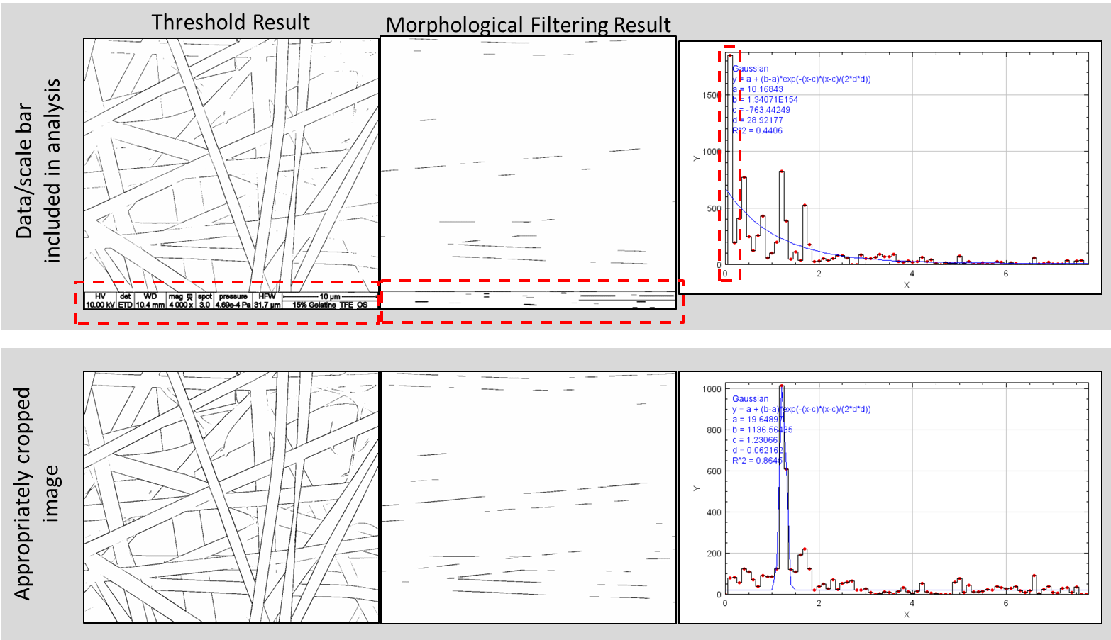

**Figure 7**: This figure shows an example of the same image processed with the image data included and cropped out. In the top example, image processing steps applied to the remaining text generate erroneous small distance measurements and lead to a Gaussian fit with a negative number (red boxes).

## Bin number error

A possible error message while using the GIFT macro is “max bins> 9999”. This indicates that while trying to generate a histogram, there would have been more than the maximum number of bins created. It is unlikely that this will occur during normal use and is probably because of an accidental error in the bin size or the scale and likely occurred while processing the first image in the folder. First make sure that the bin size used is appropriate for the situation. See the discussion and example in the Parameter 8. Make sure that the bin size is appropriate for the scale and units being used. Second, check that the scale has been entered appropriately. Accidently inverting the scale values (i.e. entering 1 px/50 µm instead of 50 px/1µm) can cause this error. If the error is not due to erroneous parameter entries, then try increasing the bin size to reduce the total number of bins.

## Bimodal distributions

In its current form, GIFT can only fit distributions with a single peak. This means that it cannot automatically measure the fiber diameters of electro spun nonwovens that have 2 or more discrete fiber sizes. For examples, nonwoven made with co-electropinning of 2 solutions, each of which makes fibers with different diameters. In this case, the histogram of measured distances would be bimodal. The Gaussian fit used in ImageJ cannot detect multiple peaks and the results are therefore inaccurate. The example in Figure 8 shows the results of using GIFT to analyze nonwovens with multiple fiber diameters. In this case, both fiber sizes are visible in the histogram as distinct peaks, but the Gaussian fit is not appropriate. Often this type of distribution will result in a negative “mean diameter”. However, it may be possible to use the histogram and/raw data to individually fit each peak in different software.

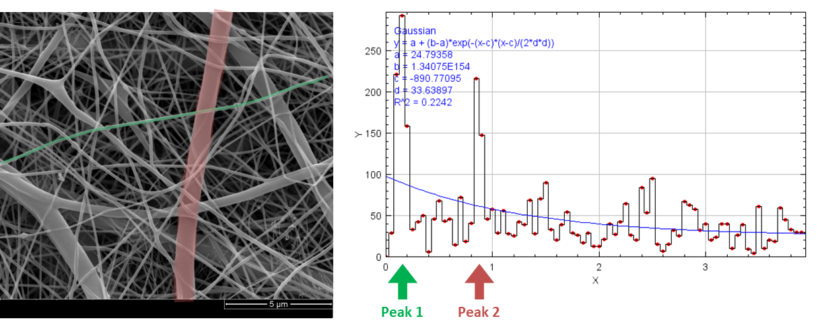

**Figure 8:** The SEM image shown on the right is an example of an electrospun nonwoven with two distinct fiber sizes. An example of the smaller fiber type is highlighted in green and an example of the larger fiber type is highlighted in red. The resulting histogram is shown on the left. There are two distinct peaks: Peak 1 at ~0.1 µm and Peak 2 at ~0.9 µm. These peaks correspond to the expected fiber diameters based on the image, however the resulting Gaussian fit is not well suited to bimodal distributions and therefore generates inaccurate results.

References

[1] A. Götz, V. Senz, W. Schmidt, J. Huling, N. Grabow, S. Illner, General image fiber tool: A concept for automated evaluation of fiber diameters in SEM images, Measurement 177 (2021) 109265. https://doi.org/10.1016/j.measurement.2021.109265.

[2] C.A. Schneider, W.S. Rasband, K.W. Eliceiri, NIH Image to ImageJ: 25 years of image analysis, Nat Methods 9 (2012) 671–675. https://doi.org/10.1038/nmeth.2089.

[3] J. Schindelin, I. Arganda-Carreras, E. Frise, V. Kaynig, M. Longair, T. Pietzsch, S. Preibisch, C. Rueden, S. Saalfeld, B. Schmid, J.-Y. Tinevez, D.J. White, V. Hartenstein, K. Eliceiri, P. Tomancak, A. Cardona, Fiji: an open-source platform for biological-image analysis, Nat Methods 9 (2012) 676–682. https://doi.org/10.1038/nmeth.2019.

[4] D. Legland, I. Arganda-Carreras, P. Andrey, MorphoLibJ: integrated library and plugins for mathematical morphology with ImageJ, Bioinformatics 32 (2016) 3532–3534. https://doi.org/10.1093/bioinformatics/btw413.